**Usability Testing – ATTENDED TESTING PRACTICAL**

**Personal Test plan**

|  |  |
| --- | --- |
| **Accessibility** | Complete |
| Site Load-time Is Reasonable | Y |
| Adequate Text-to-Background Contrast | Y – Checked with online contrast checker |
| Font Size/Spacing Is Easy to Read | Y |
| Flash & Add-ons Are Used Sparingly | Y |
| Images Have Appropriate ALT Tags | Y |
| Site Has Custom Not-found/404 Page | Y |

|  |  |
| --- | --- |
| **Identity** | Complete |
| Company Logo Is Prominently Placed | Y |
| Tagline Makes Company's Purpose Clear | Y |
| Home-page Is Digestible In 5 Seconds | Y |
| Clear Path to Company Information | N/A |
| Clear Path to Contact Information | N/A |
| Text input box labelled appropriately | Y |

|  |  |
| --- | --- |
| **Navigation** | Complete |
| Main Navigation Is Easily Identifiable | Y |
| Navigation Labels Are Clear & Concise | Y |
| Number of Buttons/Links Is Reasonable | Y |
| Company Logo Is Linked to Home-page | Y |
| Links Are Consistent & Easy to Identify | Y |
| Site Search Is Easy to Access | N/A |
| Buttons link to the right place | Y |

|  |  |
| --- | --- |
| **Content** | Complete |
| Major Headings Are Clear & Descriptive | Y |
| Critical Content Is Above The Fold | Y |
| Styles & Colours Are Consistent | Y |
| Emphasis (bold, etc.) Is Used Sparingly | Y |
| Ads & Pop-ups Are Unobtrusive | Y |
| Main Copy Is Concise & Explanatory | ? |
| URLs Are Meaningful & User-friendly | Y |
| HTML Page Titles Are Explanatory | Y |
| Appropriate use of white space |  |

**HTML validator results**

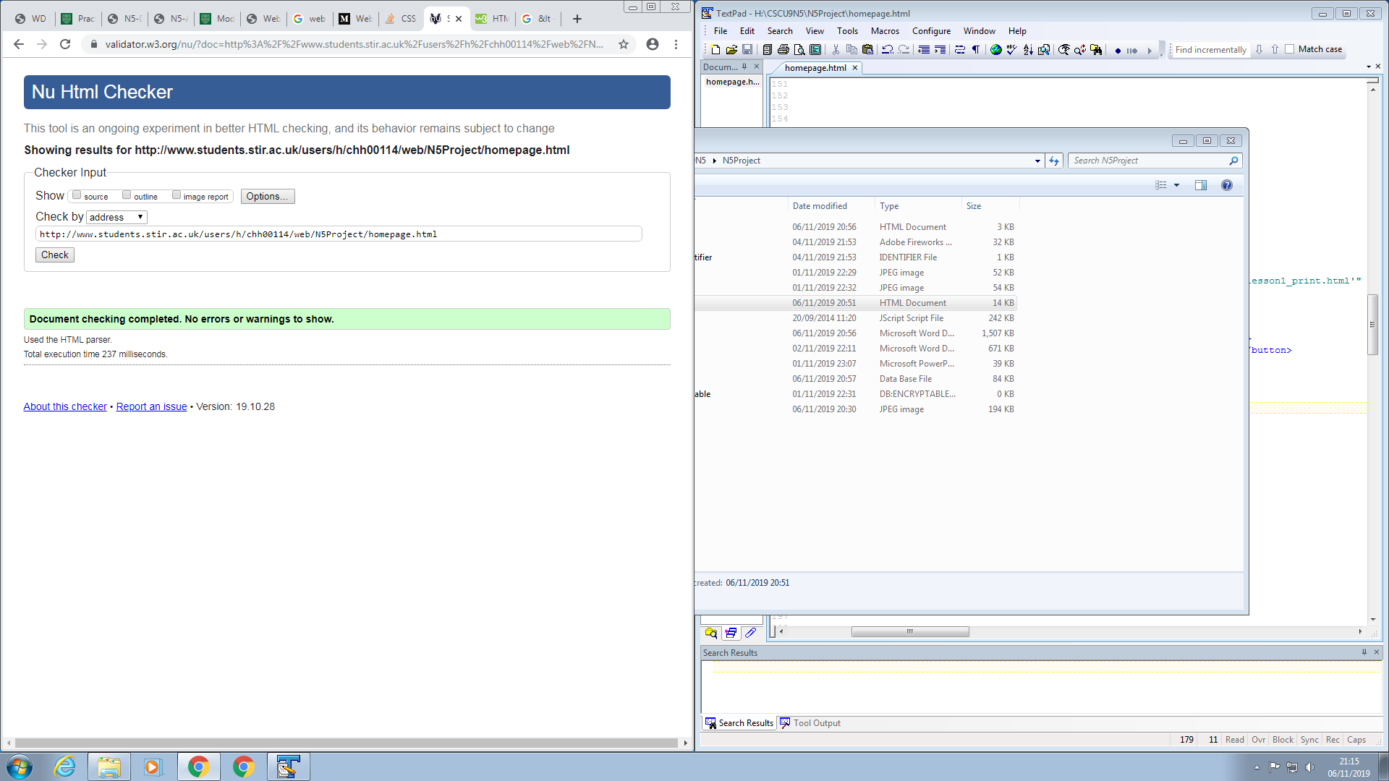

**Different window sizes**

Displays well on mobile and when using different window sizes.

**Colour blindness checker results**

Image on the left is the website background against the text colour. It’s a pass.

Image on the right is the background colour of the buttons against the button text colour. Also a pass.

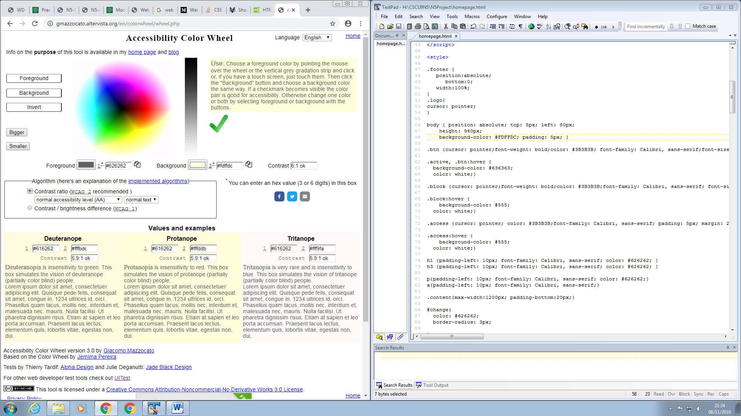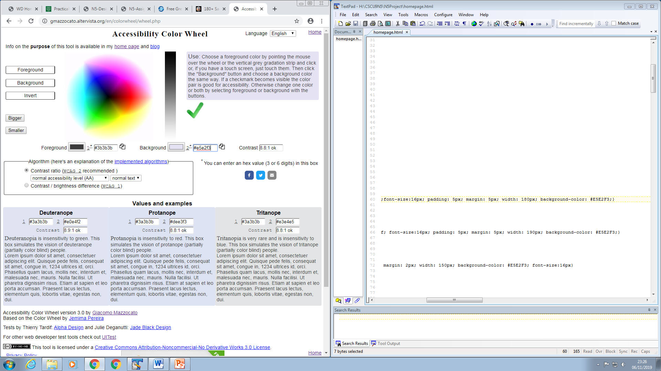

Also the JavaScript canvas that draws blue on a white background also passes the colour blind test.

**Testing Script**

*Instructions for the User*

Your job is to do the tests and say what you're doing out loud. Be yourself. Follow the instructions given by the test master and be sure to keep talking about what you see and why you choose an action.

*Instructions for the Facilitator*

Your job is to make the user feel comfortable, and to tell them what the tasks are you want them to do. Make sure they keep talking to you. You are not there to tell them what to click on or to explain the web page to them. Follow the test script overleaf.

*Instructions for the Observer*

You watch what's happening, listen to what the user says, and make notes about what you think this means for the web site. We will be collecting in the notes at the end to copy, so please write legibly. Read the test script so you know what happens in advance.

**TEST**

**To begin:**

TRUNK TEST

Trunk Text Example: <http://www.ailedgarcia.com/229/lessons/TrunkTestNavigation.pdf>

Identify the following as quickly as you can. Say out loud once you have found the element. *Observer note if there is trouble identifying a particular element.*

* Site ID/Logo
* Sections
  + Subsections
* Current Page Name
* Local navigation
* ‘You Are Here’ Indicators

**Secondly,** ‘**Don’t Make Me Think’**

The user should not have to think about how the website is to be used. It should be obvious.

What is your opinion on the general appearance of the website?

* Do you have to think greatly about the general layout? Is the content organised neatly and logically?
* Is it obvious what all buttons should do?
* Are you able to scan each page and get an idea of its content?
* What is your opinion on the colour scheme?

**Now for more tasks… Please think out loud as you are completing them….**

FACILITATOR: go through the tasks and ask the user to carry it out.

1. Adjust the font size of the website
2. Find the page about JavaScript, and then return to the homepage.
3. Find out about the function of the <BODY> tag in an HTML document
4. Try out the CSS example to change the texts colour
5. Find out what JavaScript is.
6. Draw something on, then clear, the JavaScript canvas
7. Watch the CSS tutorial video

Ask if there is any other feedback.

Observer is there any feedback?

Thank you very much for participating.